**QUESTION TWO PART 1**

**FLOW CHART**

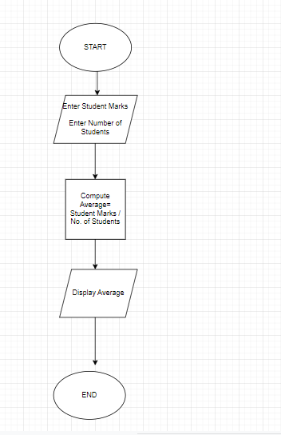

**QUESTION TWO PART 2**

**FLOW CHART**

